JavaScript Assignment #3

**Part 1: What’s your name? Using a Products Form**

[Paste your part 1 screen shot below]

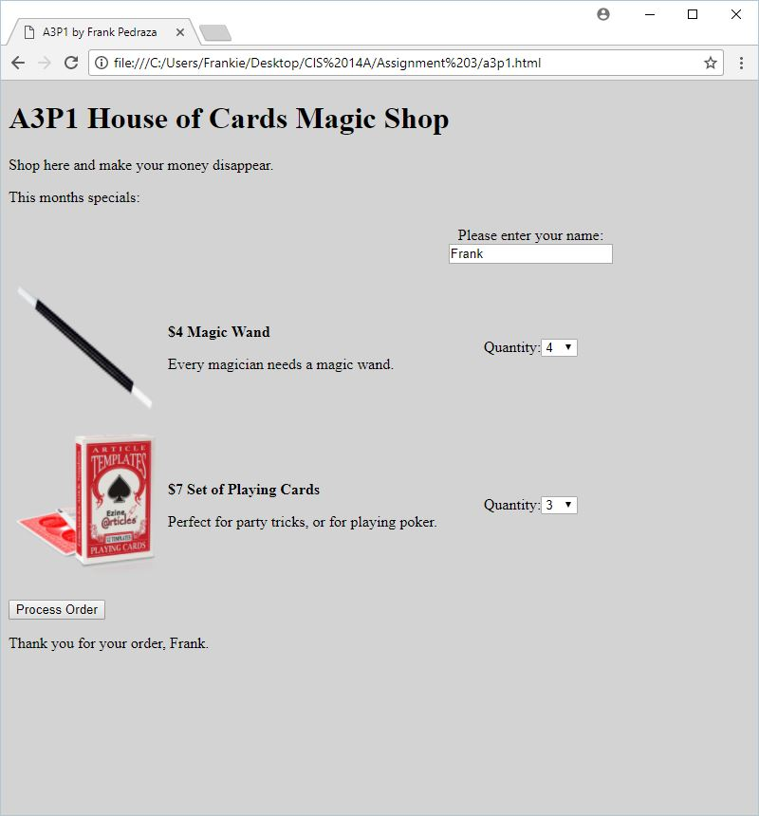

[Paste your part 1 Code below]

<!DOCTYPE html>

<html lang="en">

<head>

<meta charset="utf-8">

<title>A3P1 by Frank Pedraza</title>

<style>

body {

background-color: lightgrey;

}

table {

border: none;

}

tbody tr td {

border: none;

}

.col3 {

text-align: center;

}

</style>

</head>

<body>

<h1>A3P1 House of Cards Magic Shop</h1>

<p>Shop here and make your money disappear.</p>

<p>This months specials:</p>

<form>

<table border="1" cellspacing="0" cellpadding="6" summary="Table of product images, prices & descriptions">

<tbody>

<tr>

<td>&nbsp;</td>

<td>&nbsp;</td>

<td class="col3">Please enter your name:<br><input type="text" id="txtName" name="txtName">

</td>

</tr>

<tr>

<td><img src="Images/magic_wand.png" alt="Magic Wand" height="150" width="150"></td>

<td><p style="font-weight: bold">$4 Magic Wand</p>

<p>Every magician needs a magic wand.</p></td>

<td class="col3">Quantity:<select id="txtQ1">

<option>0</option>

<option>1</option>

<option>2</option>

<option>3</option>

<option>4</option>

<option>5</option>

<option>6</option>

<option>7</option>

<option>8</option>

<option>9</option>

<option>10</option>

</select></td>

</tr>

<tr>

<td><img src="Images/cards.png" alt="Playing Cards" height="150" width="150"></td>

<td><p style="font-weight: bold">$7 Set of Playing Cards</p>

<p>Perfect for party tricks, or for playing poker.</p></td>

<td class="col3">Quantity:<select id="txtQ2">

<option>0</option>

<option>1</option>

<option>2</option>

<option>3</option>

<option>4</option>

<option>5</option>

<option>6</option>

<option>7</option>

<option>8</option>

<option>9</option>

<option>10</option>

</select></td>

</tr>

</tbody>

</table>

<p>

<input type="button" value="Process Order" id="btnProcess"

onClick="var objName=document.getElementById('txtName');

var strName=objName.value;

var strSentence='Thank you for your order, '+strName+'.'; document.getElementById('receipt').innerHTML=strSentence;">

</p>

</form>

<div id="receipt">&nbsp;</div>

</body>

</html>

**Part 2: Make it Functional!**

[Paste your part 2 screen shot below]

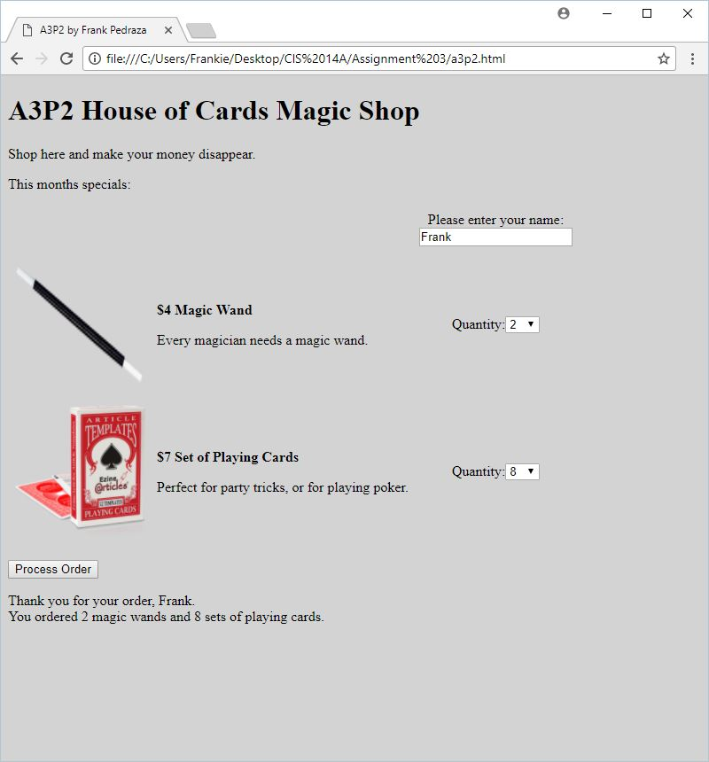

[Paste your part 2 Code below]

<!DOCTYPE html>

<html lang="en">

<head>

<meta charset="utf-8">

<title>A3P2 by Frank Pedraza</title>

<script>

var wandPrice=4;

var cardsPrice=7;

function processOrder(){

var objName=document.getElementById('txtName');

var strName=objName.value;

var numWands=document.getElementById('txtQ1').value;

var numCards=document.getElementById('txtQ2').value;

var strSentence='Thank you for your order, '+strName+'.<br>You ordered '+numWands+' magic wands and '+numCards+' sets of playing cards.';

document.getElementById('receipt').innerHTML=strSentence;

}

</script>

<style>

body {

background-color: lightgrey;

}

table {

border: none;

}

tbody tr td {

border: none;

}

.col3 {

text-align: center;

}

</style>

</head>

<body>

<h1>A3P2 House of Cards Magic Shop</h1>

<p>Shop here and make your money disappear.</p>

<p>This months specials:</p>

<form>

<table border="1" cellspacing="0" cellpadding="6" summary="Table of product images, prices & descriptions">

<tbody>

<tr>

<td>&nbsp;</td>

<td>&nbsp;</td>

<td class="col3">Please enter your name:<br><input type="text" id="txtName" name="txtName">

</td>

</tr>

<tr>

<td><img src="Images/magic_wand.png" alt="Magic Wand" height="150" width="150"></td>

<td><p style="font-weight: bold">$<script>document.write(wandPrice)</script> Magic Wand</p>

<p>Every magician needs a magic wand.</p></td>

<td class="col3">Quantity:<select id="txtQ1">

<option>0</option>

<option>1</option>

<option>2</option>

<option>3</option>

<option>4</option>

<option>5</option>

<option>6</option>

<option>7</option>

<option>8</option>

<option>9</option>

<option>10</option>

</select></td>

</tr>

<tr>

<td><img src="Images/cards.png" alt="Playing Cards" height="150" width="150"></td>

<td><p style="font-weight: bold">$<script>document.write(cardsPrice)</script> Set of Playing Cards</p>

<p>Perfect for party tricks, or for playing poker.</p></td>

<td class="col3">Quantity:<select id="txtQ2">

<option>0</option>

<option>1</option>

<option>2</option>

<option>3</option>

<option>4</option>

<option>5</option>

<option>6</option>

<option>7</option>

<option>8</option>

<option>9</option>

<option>10</option>

</select></td>

</tr>

</tbody>

</table>

<p>

<input type="button" value="Process Order" id="btnProcess"

onClick="processOrder()">

</p>

</form>

<div id="receipt">&nbsp;</div>

</body>

</html>

**Part 3: You Receive A Receipt!**  
 [Page Your part 3 Screenshot below]

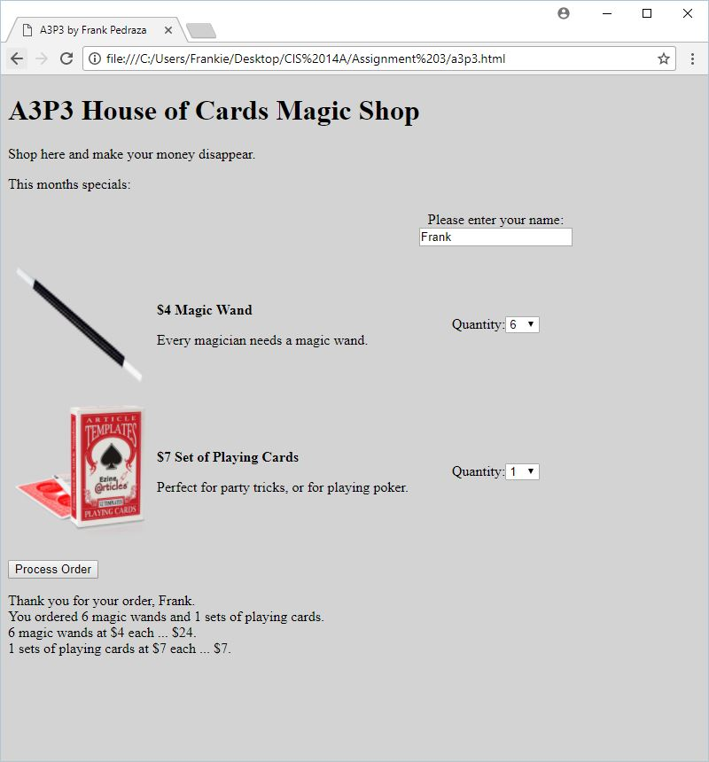

[Paste your part 3 Code Below your screen shot]

<!DOCTYPE html>

<html lang="en">

<head>

<meta charset="utf-8">

<title>A3P3 by Frank Pedraza</title>

<script>

var wandPrice=4;

var cardsPrice=7;

function processOrder(){

var objName=document.getElementById('txtName');

var strName=objName.value;

var numWands=document.getElementById('txtQ1').value;

var numCards=document.getElementById('txtQ2').value;

var wandTotal=numWands*wandPrice;

var cardsTotal=numCards*cardsPrice;

var strSentence='Thank you for your order, '+strName+'.<br>You ordered '+numWands+' magic wands and '+numCards+' sets of playing cards.<br>'+numWands+' magic wands at $'+wandPrice+' each ... $'+wandTotal+'.<br>'+numCards+' sets of playing cards at $'+cardsPrice+' each ... $'+cardsTotal+'.';

document.getElementById('receipt').innerHTML=strSentence;

}

</script>

<style>

body {

background-color: lightgrey;

}

table {

border: none;

}

tbody tr td {

border: none;

}

.col3 {

text-align: center;

}

</style>

</head>

<body>

<h1>A3P3 House of Cards Magic Shop</h1>

<p>Shop here and make your money disappear.</p>

<p>This months specials:</p>

<form>

<table border="1" cellspacing="0" cellpadding="6" summary="Table of product images, prices & descriptions">

<tbody>

<tr>

<td>&nbsp;</td>

<td>&nbsp;</td>

<td class="col3">Please enter your name:<br><input type="text" id="txtName" name="txtName">

</td>

</tr>

<tr>

<td><img src="Images/magic_wand.png" alt="Magic Wand" height="150" width="150"></td>

<td><p style="font-weight: bold">$<script>document.write(wandPrice)</script> Magic Wand</p>

<p>Every magician needs a magic wand.</p></td>

<td class="col3">Quantity:<select id="txtQ1">

<option>0</option>

<option>1</option>

<option>2</option>

<option>3</option>

<option>4</option>

<option>5</option>

<option>6</option>

<option>7</option>

<option>8</option>

<option>9</option>

<option>10</option>

</select></td>

</tr>

<tr>

<td><img src="Images/cards.png" alt="Playing Cards" height="150" width="150"></td>

<td><p style="font-weight: bold">$<script>document.write(cardsPrice)</script> Set of Playing Cards</p>

<p>Perfect for party tricks, or for playing poker.</p></td>

<td class="col3">Quantity:<select id="txtQ2">

<option>0</option>

<option>1</option>

<option>2</option>

<option>3</option>

<option>4</option>

<option>5</option>

<option>6</option>

<option>7</option>

<option>8</option>

<option>9</option>

<option>10</option>

</select></td>

</tr>

</tbody>

</table>

<p>

<input type="button" value="Process Order" id="btnProcess">

</p>

</form>

<div id="receipt">&nbsp;</div>

<script>

document.getElementById('btnProcess').addEventListener("click", processOrder);

</script>

</body>

</html>

**Part 4: Change Your Prices and Pay Your Taxes!**

[Page Your part 4 Screenshot below]

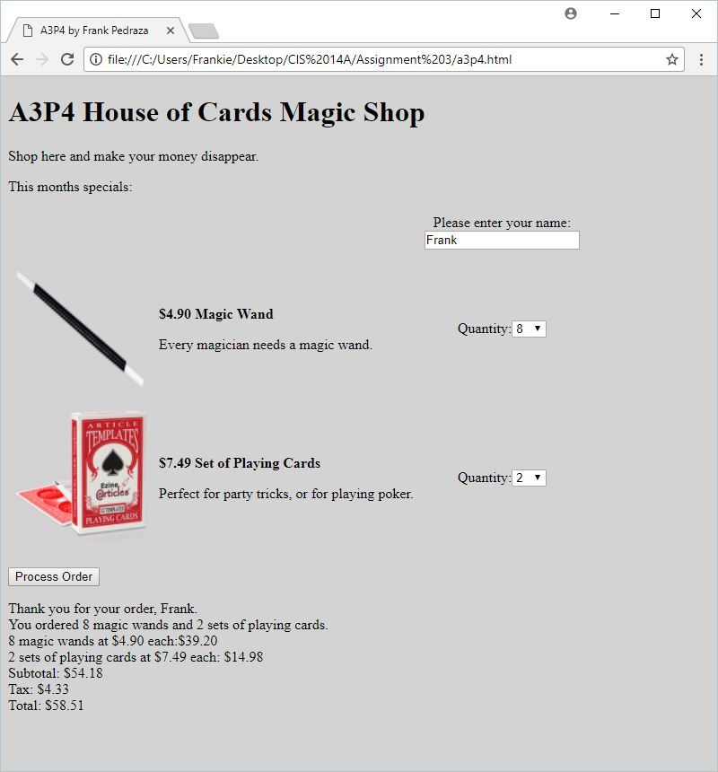

[Paste your part 4 Code Below your screen shot]

<!DOCTYPE html>

<html lang="en">

<head>

<meta charset="utf-8">

<title>A3P4 by Frank Pedraza</title>

<script>

var wandPrice=4.90;

var cardsPrice=7.49;

function processOrder(){

var strTab='&nbsp;&nbsp;&nbsp;&nbsp;';

var objName=document.getElementById('txtName');

var strName=objName.value;

var numWands=document.getElementById('txtQ1').value;

var numCards=document.getElementById('txtQ2').value;

var wandTotal=numWands*wandPrice;

var cardsTotal=numCards*cardsPrice;

var subTotal=wandTotal+cardsTotal;

var tax=subTotal*0.08;

var total=subTotal+tax;

var strSentence='Thank you for your order, '+strName+'.<br>You ordered '+numWands+' magic wands and '+numCards+' sets of playing cards.<br>';

var strWands=numWands+' magic wands at $'+wandPrice.toFixed(2)+' each:$'+wandTotal.toFixed(2)+'<br>';

var strCards=numCards+' sets of playing cards at $'+cardsPrice.toFixed(2)+' each: $'+cardsTotal.toFixed(2)+'<br>';

var strSubTotal='Subtotal: $'+subTotal.toFixed(2)+'<br>';

var strTax='Tax: $'+tax.toFixed(2)+'<br>';

var strTotal='Total: $'+total.toFixed(2)+'<br>';

document.getElementById('receipt').innerHTML=strSentence+strWands+strCards+strSubTotal+strTax+strTotal;

}

</script>

<style>

body {

background-color: lightgrey;

}

table {

border: none;

}

tbody tr td {

border: none;

}

.col3 {

text-align: center;

}

</style>

</head>

<body>

<h1>A3P4 House of Cards Magic Shop</h1>

<p>Shop here and make your money disappear.</p>

<p>This months specials:</p>

<form>

<table border="1" cellspacing="0" cellpadding="6" summary="Table of product images, prices & descriptions">

<tbody>

<tr>

<td>&nbsp;</td>

<td>&nbsp;</td>

<td class="col3">Please enter your name:<br><input type="text" id="txtName" name="txtName">

</td>

</tr>

<tr>

<td><img src="Images/magic_wand.png" alt="Magic Wand" height="150" width="150"></td>

<td><p style="font-weight: bold">$<script>document.write(wandPrice.toFixed(2))</script> Magic Wand</p>

<p>Every magician needs a magic wand.</p></td>

<td class="col3">Quantity:<select id="txtQ1">

<option>0</option>

<option>1</option>

<option>2</option>

<option>3</option>

<option>4</option>

<option>5</option>

<option>6</option>

<option>7</option>

<option>8</option>

<option>9</option>

<option>10</option>

</select></td>

</tr>

<tr>

<td><img src="Images/cards.png" alt="Playing Cards" height="150" width="150"></td>

<td><p style="font-weight: bold">$<script>document.write(cardsPrice.toFixed(2))</script> Set of Playing Cards</p>

<p>Perfect for party tricks, or for playing poker.</p></td>

<td class="col3">Quantity:<select id="txtQ2">

<option>0</option>

<option>1</option>

<option>2</option>

<option>3</option>

<option>4</option>

<option>5</option>

<option>6</option>

<option>7</option>

<option>8</option>

<option>9</option>

<option>10</option>

</select></td>

</tr>

</tbody>

</table>

<p>

<input type="button" value="Process Order" id="btnProcess">

</p>

</form>

<div id="receipt">&nbsp;</div>

<script>

document.getElementById('btnProcess').addEventListener("click", processOrder);

</script>

</body>

</html>